

**MATHEMATICS  
APPLICATIONS**

**Test 2 – Linear Models and Sequences**

**Chapters 2 and 3**

**Semester 1 2017**

# 

**Section One - Calculator Free**

Time allowed for this section

Working time for this section: 30 minutes

Marks available: 32 marks

## Material required/recommended for this section

##### To be provided by the supervisor

This Question/Answer booklet

Formula sheet

##### To be provided by the candidate

Standard items: pens, pencils, pencil sharpener, eraser, correction fluid, ruler, highlighters

Special items: Nil

## Important note to candidates

No other items may be used in this section of the examination. It is **your** responsibility to ensure that you do not have any unauthorised notes or other items of a non-personal nature in the examination room. If you have any unauthorised material with you, hand it to the supervisor **before** reading any further.

1. (3 marks)  
     
   Calculate the sum of all the **multiples of 5** between 1 and 50.
2. (4 marks: 2, 2)  
     
   Below are four consecutive numbers of an arithmetic sequence. The middle two numbers are missing.  
     
    22, ……. , ……. , 76
3. What are the two missing numbers?

b) Determine the general rule for Tn

1. (3 marks: 1, 2)  
     
   For the sequence, −4, 32, −256, ...
2. Find the common ratio
3. Determine the rule for the nth term
4. (7 marks: 1, 1, 1, 2, 2)  
     
   The terms of a sequence are shown in the graph below.

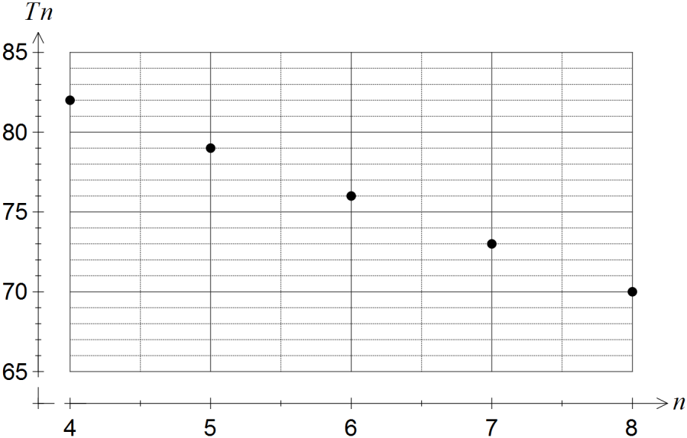

1. Describe the feature of the graph that indicates the sequence is arithmetic.
2. Determine

(i)  T9

(ii)  T1

1. The rule for the *n*th term of the sequence is Tn *= an + b*. Determine the values of theconstants *a* and *b*.
2. Determine the smallest value of *n* such that *Tn* < 0 .

|  |  |  |  |  |  |  |  |  |
| --- | --- | --- | --- | --- | --- | --- | --- | --- |
|  | Chemistry (*x*) | 2 | 3 | 5 | 6 | 7 | 9 | 9 |
|  | Physics (*y*) | 2 | 4 | 3 | 6 | E | 7 | 8 |

1. (15 marks: 3, 2, 2, 4, 3, 1)  
     
   The marks for Chemistry and Physics tests (out of 10) were recorded in the table below for 6 students:
2. Draw a scatterplot to represent this information

|  |  |  |  |  |  |  |  |  |  |  |  |
| --- | --- | --- | --- | --- | --- | --- | --- | --- | --- | --- | --- |
|  |  |  |  |  |  |  |  |  |  |  |  |
|  |  |  |  |  |  |  |  |  |  |  |  |
|  |  |  |  |  |  |  |  |  |  |  |  |
|  |  |  |  |  |  |  |  |  |  |  |  |
|  |  |  |  |  |  |  |  |  |  |  |  |
|  |  |  |  |  |  |  |  |  |  |  |  |
|  |  |  |  |  |  |  |  |  |  |  |  |
|  |  |  |  |  |  |  |  |  |  |  |  |
|  |  |  |  |  |  |  |  |  |  |  |  |
|  |  |  |  |  |  |  |  |  |  |  |  |
|  |  |  |  |  |  |  |  |  |  |  |  |

1. Draw the line of best fit ‘by eye’ and hence estimate a Physic mark for the student who was unable to sit that test (score E).
2. Describe the relationship

The ‘Line of Best Fit’ equation for the relationship is: y = 0.7x + 0.8

1. Complete the table of residuals to 1 d.p.

|  |  |  |  |  |  |  |  |
| --- | --- | --- | --- | --- | --- | --- | --- |
|  | Chemistry (x) | 2 | 3 | 5 | 6 | 9 | 9 |
|  | Physics (*y*) | 2 | 4 | 3 | 6 | 7 | 8 |
|  | Predicted Physics | 2.2 |  |  |  |  | 7.1 |
|  | Residual | -0.2 |  |  |  |  | 0.9 |

1. Draw a residual plot.

|  |  |  |  |  |  |  |  |  |  |  |  |
| --- | --- | --- | --- | --- | --- | --- | --- | --- | --- | --- | --- |
|  |  |  |  |  |  |  |  |  |  |  |  |
|  |  |  |  |  |  |  |  |  |  |  |  |
|  |  |  |  |  |  |  |  |  |  |  |  |
|  |  |  |  |  |  |  |  |  |  |  |  |
|  |  |  |  |  |  |  |  |  |  |  |  |
|  |  |  |  |  |  |  |  |  |  |  |  |
|  |  |  |  |  |  |  |  |  |  |  |  |
|  |  |  |  |  |  |  |  |  |  |  |  |
|  |  |  |  |  |  |  |  |  |  |  |  |
|  |  |  |  |  |  |  |  |  |  |  |  |
|  |  |  |  |  |  |  |  |  |  |  |  |

1. Using the residual plot, decide if the data being investigated is linear or non-linear.

**End of Section One**